1. **PROJECT OVERVIEW**

We consider the problem of high level scene understanding for personal robots. One of the original goals of computer vision was to fully understand a natural scene. This requires solving several sub-tasks simultaneously, including object detection, labelling of meaningful regions, and 3D reconstruction. Each of these tasks in turn requires solving of problems like outlier elimination, clustering and feature calculation.

Algorithms working to solve these subtasks have to be fast. Any algorithm with time complexity greater than O(n) would be quite slow in practical applications. We show the working of algorithms that provide the necessary speed and sufficient accuracy.

We also present a scheme to make the training phase of the algorithm easy. Usually the training phase includes capturing images of objects and using them for further calculations.

1. **INTRODUCTION AND MOTIVATION**

With the advent of new-generation depth sensors, the use of three-dimensional (3-D) data is becoming increasingly popular. As these sensors are commodity hardware and sold at low cost, a rapidly growing group of people can acquire 3- D data cheaply and in real time. With the massively increased usage of 3-D data for perception tasks, it is desirable that powerful processing tools and algorithms as well as standards are available for the growing community.

The PCL core is structured in smaller of 3-D processing, which can be combined to efficiently solve common problems such as object recognition, registration of point clouds, segmentation, and surface reconstruction, without the need of re implementing all parts of a system needed to solve these subtasks. In other words, the tools and algorithms provided by PCL allow researchers and companies to better concentrate on their specific areas of expertise.

Our project of object detection or labelling of meaningful regions involves several sub-tasks like training of the objects to be labelled, determining their features and while testing segmenting objects present in the scene and identifying the objects of interest by matching their features.

**2.1. THEORY BEHIND PROJECT CONCEPT**

**The PCD (**P**oint**C**loud**D**ata) file format**

Point Cloud represents the base class in PCL for storing collections of 3D points.

PCD is used to support 3D point cloud data.

The PCD file format is not meant to reinvent the wheel, but rather to complement existing file formats that for one reason or another did not/do not support some of the extensions that PCL brings to n-D point cloud processing.

PCD file contains header that identifies properties of point cloud data.

File format header contains the following elements:

* **VERSION -** specifies the PCD file version
* **FIELDS -** specifies the name of each dimension/field that a point can have.
* **SIZE -** specifies the size of each dimension in bytes.
* **TYPE -** specifies the type of each dimension as a char.
* **WIDTH -** specifies the width of the point cloud dataset in the number of points. It can specify the width (total number of points in a row) of an organized point cloud dataset.
* **HEIGHT -** specifies the height of the point cloud dataset in the number of points. It is set to 1 for unorganized datasets (thus used to check whether a dataset is organized or not).
* **VIEWPOINT -** specifies an acquisition viewpoint for the points in the dataset. This could potentially be later on used for building transforms between different coordinate systems, or for aiding with features such as surface normals, that need a consistent orientation.
* **POINTS -** specifies the total number of points in the cloud. As of version 0.7, its purpose is a bit redundant, so we’re expecting this to be removed in future versions.
* **DATA -** specifies the data type that the point cloud data is stored in. As of version 0.7, two data types are supported: ascii and binary.

**PFH Algorithm:**

The computation of a PFH at a point p relies on the presence of 3D coordinates and estimated surface normals, and is computed as follows:

1. For each point p, all of p’s neighbors enclosed in the sphere with a given radius r are selected (k-neighborhood)
2. For every pair of points pi and pj (i ≠ j) in the k-neighborhood of p and their estimated normals ni and nj (pi being the point with a smaller angle between its associated normal and the line connecting the points), we define a Darboux uvn frame (u = ni ; v = (pj - pi) x u ; w = u x v) chosen at pi and compute the angular variations of ni and nj as follows:

α = V • nj

ϕ = u • (pj - pi) / d

θ = arctan (w • nj, u • nj)

Then, the Point Feature Histogram at a patch of points P = {pi} with i = {1 ... n} captures all the sets of <α, ϕ, θ> between all pairs of <pi, pj> from P, and bins the results in a histogram.

Figure 1 presents an influence region diagram of the PFH computation for a query point (pq). pq is marked with red and placed in the middle of a circle (sphere in 3D) with radius r, and all its k neighbours (points with distances smaller than the radius r) are fully interconnected in a mesh.



Figure 1: Influence region diagram of the PFH computation

The theoretical computational complexity of the Point Feature Histogram for a given point cloud P with n points is O(n • k2), where k is the number of neighbors for each point p in P. A straightforward optimization is to cache feature values and reorder the point cloud dataset so that performing lookups in a data container becomes faster than re-computing the values.

For real-time or near real-time applications however, the computation of Point Feature Histograms in dense point neighborhoods can represent one of the major bottlenecks in the registration framework.

**FPFH Algorithm:**

To simplify the histogram feature computation, we proceed as follows:

1. In a first step, for each query point p we compute only the relationships (see Equation 1) between itself and its neighbors – we will call this the Simplified Point Feature Histogram (SPFH)
2. Then in a second step, for each point we re-determine its k neighbors and use the neighboring SPFH values to weight the final histogram of p (called FPFH):

FPFH (p) = SPF (p) + 1/ k • Σi=1 k (1 / wk) • SPF (pk)

where the weight wk represents the distance between query point p and a neighbor point pk in a given metric space.



Figure 2: The influence region diagram for a Fast Point Feature Histogram.

Each query point (red) is connected only to its direct k-neighbors (enclosed

by the gray circle). Each direct neighbor is connected to its own neighbors

and the resulted histograms are weighted together with the histogram of

the query point to form the FPFH. The connections marked with 2 will contribute to the FPFH twice.

Because all possible pairs of points are considered, the computation complexity of a PFH is O(n2) in the number of surface normals n. In order to make a more efficient algorithm, the Fast Point Feature Histogram was developed. The FPFH measures the same angular features as PFH, but estimates the sets of values only between every point and its k nearest neighbours, followed by a reweighting of the resultant histogram of a point with the neighbouring histograms, thus reducing the computational complexity to O(k * n).

For a given query point pq, we first estimate its SPFH values by creating pairs between itself and its neighbors. We repeat this for all the points in the dataset, and then we re-weight the SPFH values of pk using the SPFH values of its neighbors, thus creating the FPFH for pq. As the diagram shows, some of the value pairs will be counted twice (marked with 2 in the figure). The differences between PFH and FPFH are:

1. The FPFH does not fully interconnect all neighbors of pq as it can be seen from Figures 1 and 5, and is thus missing some value pairs which might contribute to capture the geometry around pq
2. The PFH models a precisely determined surface around pq, while the FPFH includes additional point pairs outside the r radius sphere (though at most 2r away)
3. Because of the re-weighting scheme, the FPFH combines SPFH values and re-captures some of the point neighboring value pairs.

**VFH Algorithm:**

The VFH algorithm leverages the strong recognition results of FPFH, but adds in viewpoint variance while retaining invariance to scale, since the dense stereo depth map gives scale/distance directly. The VFH algorithm for object recognition and pose identification extends the FPFH algorithm and also computes additional statistics between the viewpoint direction and normals estimated at each point.

The viewpoint direction is mixed directly into the relative normal angle calculation in the FPFH. Figure 3 presents this idea with the new feature consisting of two parts: a viewpoint direction component and a surface shape component comprised of an extended FPFH The viewpoint component is computed by collecting a histogram of the angles that the viewpoint direction makes with each normal. The view angle is not the angle to each normal as this would not be scale invariant, but instead the angle between the central viewpoint direction translated to each normal. The second component measures the relative pan, tilt and yaw angles as described in but now measured between the viewpoint direction at the central point and each of the normals on the surface. We call the new assembled feature the Viewpoint Feature Histogram (VFH). Figure 3 presents the resultant assembled VFH for a random object

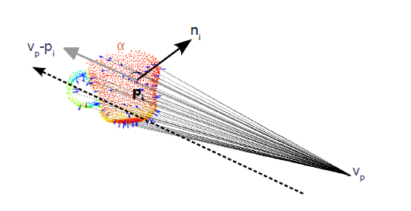

Figure 3: The Viewpoint Feature Histogram is created from the extended

Fast Point Feature Histogram as seen in Figure 3 together with the statistics

of the relative angles between each surface normal to the central viewpoint

direction.

The computational complexity of VFH is O(n). In our experiments, we divided the viewpoint angles into 128 bins and the α, ϕ and θ angles into 45 bins each or a total of 263 dimensions.

**k-Nearest-Neighbor Classifiers :**

Nearest-neighbor classifiers are based on learning by analogy, that is, by comparing a given test tuple with training tuples that are similar to it. The training tuples are described by n attributes. Each tuple represents a point in an n-dimensional space. In this way, all of the training tuples are stored in an n-dimensional pattern space. When given an unknown tuple, a k-nearest-neighbor classifier searches the pattern space for the k training tuples that are closest to the unknown tuple. These k training tuples are the k “nearest neighbors” of the unknown tuple.

“Closeness” is defined in terms of a distance metric, such as Euclidean distance.

The Euclidean distance between two points or tuples, say, X1 = (x11, x12,. . ., x1n) and X2 = (x21, x22,. . . , x2n), is

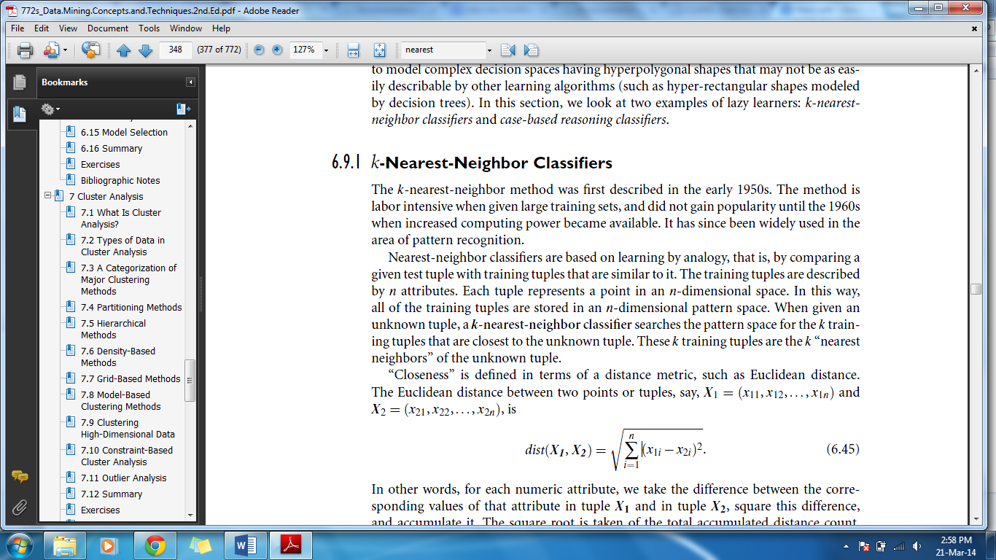

In other words, for each numeric attribute, we take the difference between the corresponding values of that attribute in tuple X1 and in tuple X2, square this difference and accumulate it. The square root is taken of the total accumulated distance count.

Typically, we normalize the values of each attribute before using Equation (6.45). This helps prevent attributes with initially large ranges (such as income) from outweighing attributes with initially smaller ranges (such as binary attributes). Min-max normalization, for example, can be used to transform value v of a numeric attribute A to v1 in the range [0, 1] by computing

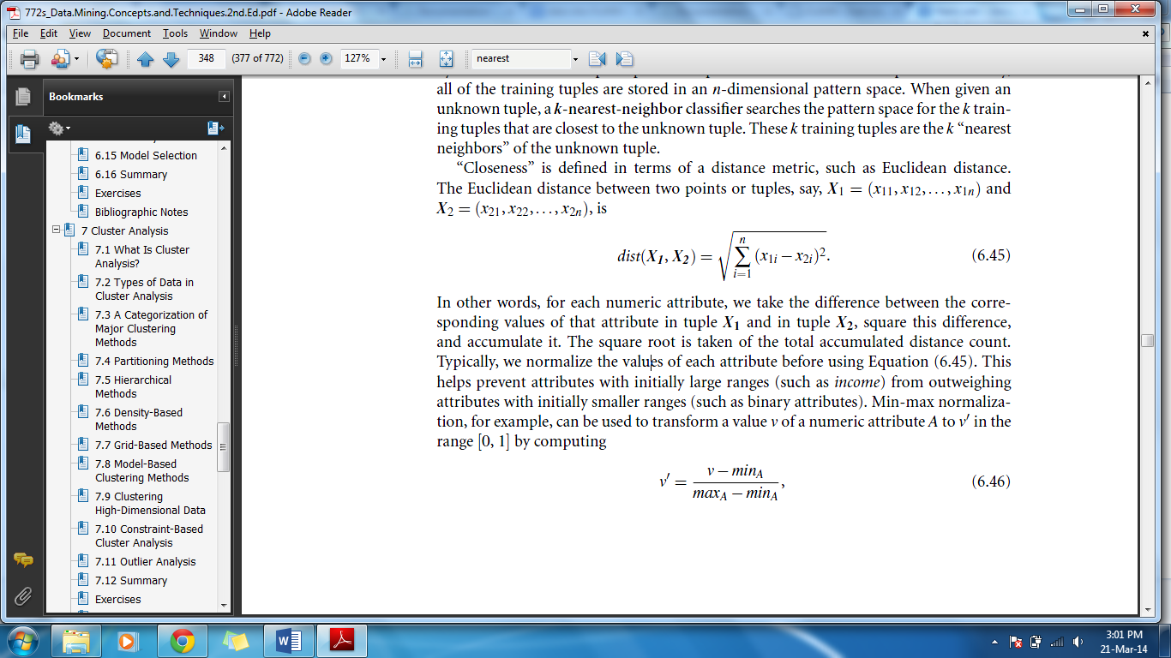

where minA and maxA are the minimum and maximum values of attribute A

For k-nearest-neighbor classification, the unknown tuple is assigned the most common class among its k nearest neighbors. When k = 1, the unknown tuple is assigned the class of the training tuple that is closest to it in pattern space. Nearest neighbor classifiers can also be used for prediction, that is, to return a real-valued prediction for a given unknown tuple. In this case, the classifier returns the average value of the real-valued labels associated with the k nearest neighbors of the unknown tuple.

**Algorithm:**

**Step 1:** Choose the number of clusters.

**Step 2:** Set the initial partition, and the initial mean vectors for each cluster.

**Step 3:** For each remaining individual...

**Step 4:** Get averages for comparison to the Cluster 1:

Add individuals A value to the sum of A values of the individuals in Cluster 1, then divide by the total number of scores that were summed.

Add individual's B value to the sum of B values of the individuals in Cluster 1, then divide by the total number of scores that were summed.

**Step 5:** Get averages for comparison to the Cluster 2:

Add individuals A value to the sum of A values of the individuals in Cluster 2, then divide by the total number of scores that were summed.

Add individual's B value to the sum of B values of the individuals in Cluster 2, then divide by the total number of scores that were summed.

**Step 6:** If the averages found in Step 4 are closer to the mean values of Cluster 1, then this individual belongs to Cluster 1, and the averages found now become the new mean vectors for Cluster 1.

If closer to Cluster 2, then it goes to Cluster 2, along with the averages as new mean vectors.

**Step 7:** If there are more individual's to process, continue again with Step 4. Otherwise go to Step 8.

**Step 8:** Now compare each individual’s distance to its own cluster's mean vector, and to that of the opposite cluster. The distance to its cluster's mean vector should be smaller than it distance to the other vector. If not, relocate the individual to the opposite cluster.

**Step 9:** If any relocations occurred in Step 8, the algorithm must continue again with Step 3, using all individuals and the new mean vectors.

If no relocations occurred, stop. Clustering is complete.

**2.2 PROBLEM DEFINITION**

Our project aims at identifying different objects in home environment. For this we use 3D data instead of plain 2D images. There are systems that do this same task in 2D domain using various image processing techniques. But there are inherent limitations in processing 2D images. We have to process images with only the color information and it can give misleading results in occluded environments. The processing of such systems really comes down to pixel-by-pixel comparison. Also the information present in the geometry of different objects cannot be used in 2D processing.



Figure 4: Problem with object identification system in 2D image

If we process the above image using 2D techniques the object identified would be a bottle and a mug which is not right. Such tasks require consideration of object geometry.

An important concern for the proper working of the system is its speed. We present the use of an algorithm which is sufficiently fast and gives us results in almost real-time. Also considering the depth data provides a significant improvement over classifiers using only 2D information (RGB information). We also get the advantage scale-invariance and pose-invariance in detection by using 3D data.

Inexpensive RGB-D sensors that augment an RGB image with depth data have recently become widely available. These cameras are increasingly becoming the de-facto standard for perception for many robots. At the same time, research has now made it possible to merge multiple RGBD images into a single point cloud, easily providing an approximate 3D model of a complete indoor scene (i.e., a room). This can be exploited to improvise existing labelling and scene recognition techniques. It is extremely useful for detecting commonly found objects in the 3D point cloud of indoor scenes obtained from such cameras.

**2.3. NEED FOR PROJECT**

Autonomous personal robotics system need to find ways of functioning in human living environments, that is, navigating and interacting with the surrounding world in an effective manner hence in our project we consider the surrounding world as indoor scene having indoor objects. This means a robot should be capable of going anywhere where it can physically fit, perform useful chores such as cleaning tables, see if a particular object is present in the room and grasp it. In order to do this we need support from complex perception routines which can recognize various structures and objects in the world.

Therefore one of the most important aspects deciding on the applicability of personal robotics in real world environments is represented by the robot’s ability to perceive and understand the semantic meanings of the objects present in the world.

Our project aims to perform the vital step of making the robot aware of his environment by detecting objects.

1. **ANALYSIS AND DESIGN**

**3.1 SOFTWARE DEVELOPMENT**

The complete development of this system can be divided into the following stages:

* Problem definition stage

This is the very first stage to develop any project. It actually defines the aim and the concept of the project. In this section the purpose i.e. why this particular project is required is explained.

* Designing block diagram

At this stage we have categorized the whole system into different individual modules. These modules (block diagrams) will be helpful in understanding the concept and working of the integrated system.

* Developing Flowchart for software

To get the logical flow of the software, the development of flowchart is having a prominent role. So we have to analyze the complete system and organized the flowchart in such a manner that one can understand the complete working of the software.

* Writing the actual code

After the development of the algorithm and flowchart we started writing the actual code with the help of algorithm and flow charts. One of the most important step, before writing the actual code that was been taken by our group was designing the graphical user interface. Thus, with the help of stated documents, we were successful in writing the actual code.

* Compiling the code

After the actual code was written, then it was being complied. At the time of compilation, many compilation errors such as syntax errors were also being corrected, if any.

* Testing

This time we tested our project for actual working, after loading the software into the client and server machine. Any errors found were removed successfully.

* Running

This is the last and final stage of development of our project. In this stage a user flowchart was made so that anyone can use this system without any difficulty.

* Documentation

After the above all procedures, the documentation of the project was being done, which covered the various topics such as project overview, implementation, designing, etc along with all the necessary figures and tables.

**3.2. FLOW OF PROJECT**

**3.2.1. PRELIMANARY SURVEY**

There is a huge body of work in the area of scene understanding and object recognition from 2D images. Previous works have focussed on several different aspects: designing good local features such as HOG (histogram-of-gradients), bag of words, and eigenvectors and eigen values of the scatter matrix, active vision for robotics, and designing good global (context) features such as GIST features. MOPED framework performs single-image and multi-image object recognition and poses estimation in complex scenes using an algorithm which iteratively estimates groups of features that are likely to belong to the same object through clustering, and then searches for object hypotheses within each of the groups.

However, the above mentioned approaches do not consider the relative arrangement of the parts of an object or of different objects with respect to each other. It has been shown that this contextual information significantly improves the performance of image-based object detectors. A number of works propose models that explicitly capture the relations between different parts of the object, e.g., part-based models, and between different objects in 2D images. However, a lot of valuable information about the shape and geometric layout of objects is lost when 2D image is formed from the corresponding 3D world. In some recent works, 3D layout or depths have been used for improving object. Here rough 3D scene geometry (e.g., main surfaces in the scene) is inferred from a single 2D image or a stereo video stream, respectively. However, the estimated geometry is not accurate enough to give significant improvements. With 3D data, we can more precisely determine the shape, size and geometric orientation of the objects, and several other properties and therefore capture much stronger context.

Visual context can also improve the performance of object detection techniques, by providing cues about an object presence. Perko and Leonardis 2010 provided a method to use contextual features and train a classifier which can predict likely locations of objects, also referred to as the ‘focus of attention’, for directing object detection. In methods using active recognition, the performance of object detection for robotics is improved by letting the robots take certain actions, such as moving to an optimal location for obtaining a different view of the object, based on measurement related to entropy. The goal here is to obtain high performance in less number of actions proposes a path planning method which selects a path where the robot obtains new views of an object, and then these views are used for training the classifiers. However, these methods only use 2D images and do not have advantage of using the rich information present in 3D data. We show that our proposed model captures context which not only helps in labelling the scene but also to infer most contextually likely locations of objects using the objects already found in the scene. This enables the robot to move to contextually likely locations and obtain better views for finding objects and improve the performance of scene labelling.

Some earlier works have tried to combine shape and colour information from multiple sensors for tasks such as object and obstacle detection. The recent availability of synchronized videos of both colour and depth obtained from RGB-D (Kinect-style) depth cameras, shifted the focus to making use of both visual as well as shape features for object detection (e.g., Lai et al., 2011a,b), 3D segmentation, human pose estimation , and human activity detection. These methods demonstrate that augmenting visual features with 3D information can enhance object detection in cluttered, real-world environments. However, these works do not make use of the contextual relationships between various objects which have been shown to be useful for tasks such as object detection and scene understanding in 2D images. Our goal is to perform semantic labelling of indoor scenes by modelling and learning several contextual relationships.

**3.2.2. FEASIBILTY STUDY**

* + - 1. **Technical Feasibility**

The libraries used to develop this project are easily available, open-source and well documented. Also good amount of research has been done in the field of 3D perception and recognition. These research papers are available online on multiple sources. The concepts can be applied to make a full working system without any compromise. Therefore we conclude that this project is technically feasible.

* + - 1. **Operational Feasibility:**

The proposed system solves the problem of object detection effectively. It provides significant benefits over 2D based systems.

* + - 1. **Cost Feasibility:**

The cost associated with this project is only that of the sensor which is around Rs.10000. This is relatively high compared to its counterparts using 2D cameras for object detection. But given the fact that the primary application of this project is in the field of robotics and the returns which are expected from its application in various fields it is not an issue. There is high benefit-for-cost.

**3.2.3. COST ANALYSIS**

For the software system, our projected costs are within reasonable financial limits. This is because we are mostly using Free and Open Source software. The costs associated are only in relation to the hardware. The costs incurred would be for the hardware components.

We require

* Microsoft Kinect which costs Rs. 10000/-

**FP BASED ESTIMATION:**

Function point estimation uses functionality as the metric since, functionality cannot ne measure directly, it is measure indirectly using other measure functional points are derived using empirical relation based on direct measure of software domain and assessment of software complexity. FP based estimation focus on information like inputs, outputs, and inquires files and external interface for class.

|  |  |  |  |  |  |
| --- | --- | --- | --- | --- | --- |
| Measurement parameter | Count | Weighting factor | | | Count |
|  |  | **Simple** | Average | Complex |  |
| Number of user inputs | 14 | **3** | 4 | 6 | 21 |
| Number of user outputs | 1 | **4** | 5 | 7 | 12 |
| Number of user inquiries | 0 | **3** | 4 | 6 | 0 |
| Number of files | 8 | **7** | 10 | 15 | 7 |
| Number of external interfaces | 1 | **5** | 7 | 10 | 0 |

Table 1: Function Point Complexity Weights

**Count Total=42+4+0+56+5=107**

|  |  |  |
| --- | --- | --- |
| No. | Parameter | Value |
| 1 | Does the System require Reliable backup and recovery? | 3 |
| 2 | Are the specialized data Communication required to transfer information to or from the application? | 4 |
| 3 | Are these distributed processing functions? | 0 |
| 4 | Is performance critical? | 4 |
| 5 | Will the system run in an existing, heavily utilized operational Environment | 4 |
| 6 | Does the system require online data entry | 0 |
| 7 | Does the online data entry require the input transaction to be built over multiple screens or operations? | 0 |
| 8 | Are the ILFs updated online? | 0 |
| 9 | Are the inputs, outputs, files or inquiries complex? | 3 |
| 10 | Is the internal processing complex? | 4 |
| 11 | Is the code designed to be reusable? | 4 |
| 12 | Are the conversion and installation included in the design? | 0 |
| 13 | Is the system designed for multiple installations in different organizations? | 4 |
| 14 | Is the application designed to facilitate change and ease of user by the user? | 4 |

Table 2: FP based parameters

Sum of **Fi=34**

**Function Point =Count Total (0.65+0.01*Fi)**

Function Point =107(0.65+0.01*37)

**Function Point =105.93**

**As per COCOMO Model:**

|  |  |  |  |
| --- | --- | --- | --- |
| **Functions** | **Optimistic Values(Lines)** | **Most Likely Values(Lines)** | **Pessimistic Values(Lines)** |
| Training | 150 | 200 | 250 |
| Testing | 600 | 700 | 800 |
| User Interface | 80 | 100 | 150 |
| **Total** | Sopt=830 | Sml=1000 | Spess=1200 |

Table 3: COCOMO analysis

S = (Sopt + 4* Sml + Spess)/6 = (830+4*1000+1200)/6 = 1005 Lines of code = 1.005 KLOC

|  |  |  |  |  |
| --- | --- | --- | --- | --- |
| Embedded | A | B | C | D |
|  | 3.6 | 1.20 | 2.5 | 0.32 |

Table 4: Values for COCOMO analysis

$Effort=a(({kloc)}^{b})$ = 3.6((1.005)1.2) = 3.62 man-months

Duration=c(E) ^ d months.

D=2.5*(3.62) ^ 0.32

**Duration=3.77 months.**

* + 1. **PROCESS MODEL**

Since the requirements which we would require in this project is known before hand and that the requirements won’t change eventually Waterfall Model would be the most apt process model for this system.

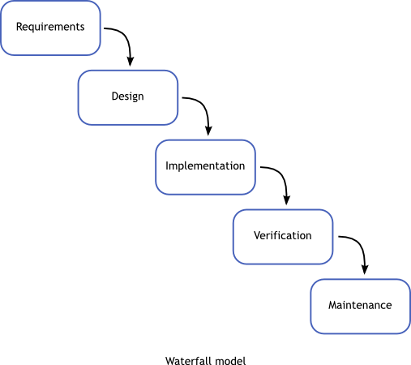

Figure 5: Process Model

The waterfall model is a sequential design process, often used in software development processes, in which progress is seen as flowing steadily downwards (like a waterfall) through the phases of:

* Requirement Gathering: Requirements are set of functionalities and constraints that the end-user (who will be using the system) expects from the system. The overall requirements was to make a system which would identify some mentioned objects or all objects present in the scene.
* Design System Design helps in specifying hardware and system requirements and also helps in defining overall system architecture. The use of Microsoft’s RGB-D camera Kinect for the implementation of the system was finalized.
* Implementation: In this phase the actual system was developed, the code was written and compiled.
* Verification: In this phase the system was tested for verifying the requirements. We made use of black box testing where multiple scenes from various angles were captured and processed to identify objects present in the scene.

Various modules were implemented in the system which were individually tested i.e. underwent unit testing and then integrated to make the complete system.

* Maintenance: This phase of "The Waterfall Model" is virtually never ending phase (Very long). Generally, problems with the system developed (which are not found during the development life cycle) come up after its practical use starts, so the issues related to the system are solved after deployment of the system. Not all the problems come in picture directly but they arise time to time and needs to be solved; hence this process referred as maintenance.

**3.2.5 Data Flow Diagrams:**

**Level 0:**

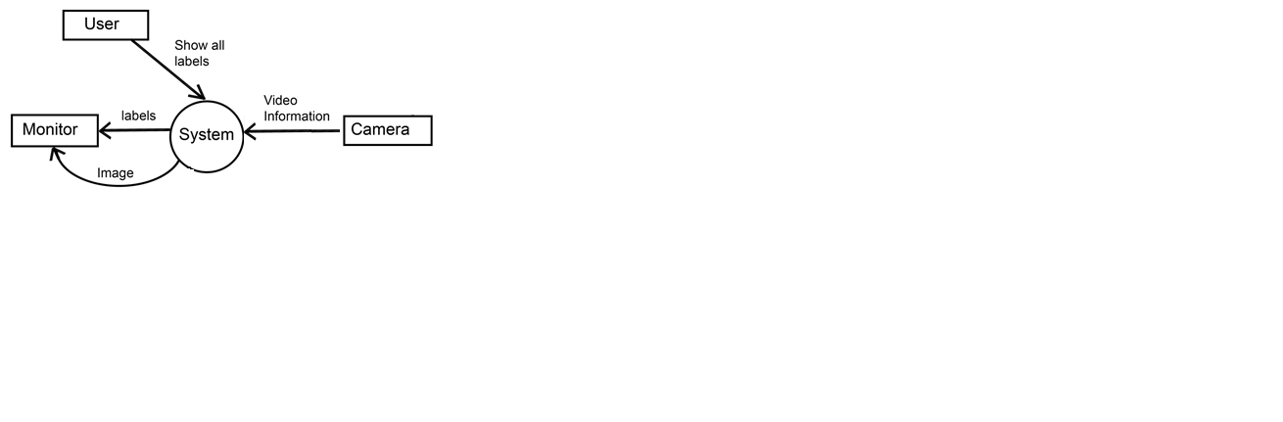

Figure 6: DFD level 0

**Level 1:**

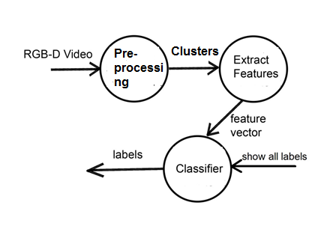

Figure 7: DFD level 1

**Level 2:**

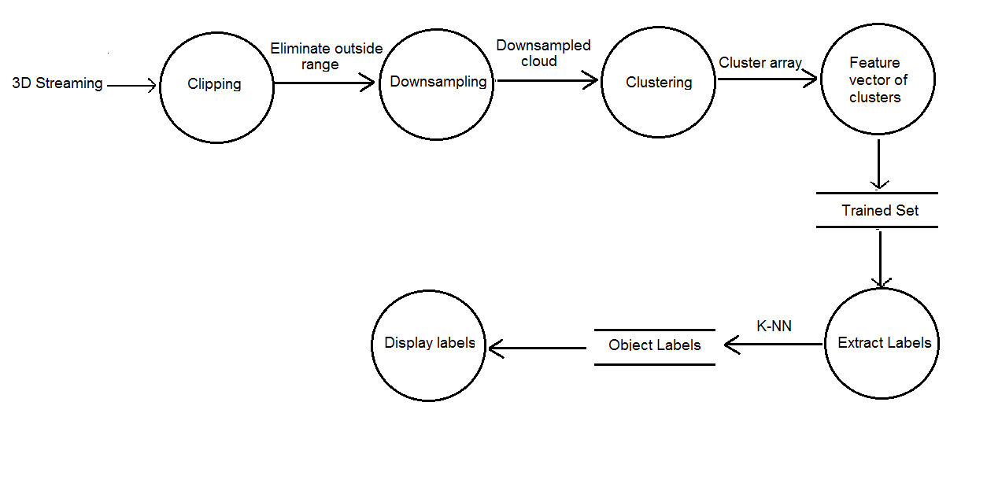Figure 8: DFD level 2

* 1. **UML diagrams:** 
     1. **Use case diagram:**

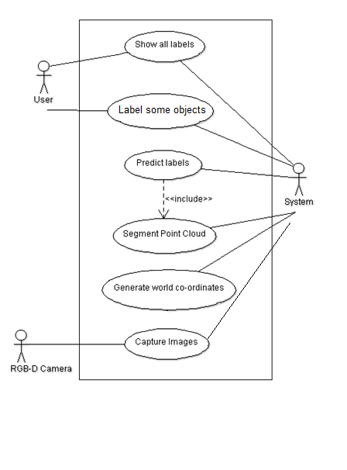

Figure 9: Use Case diagram

* + 1. **Activity diagram:**

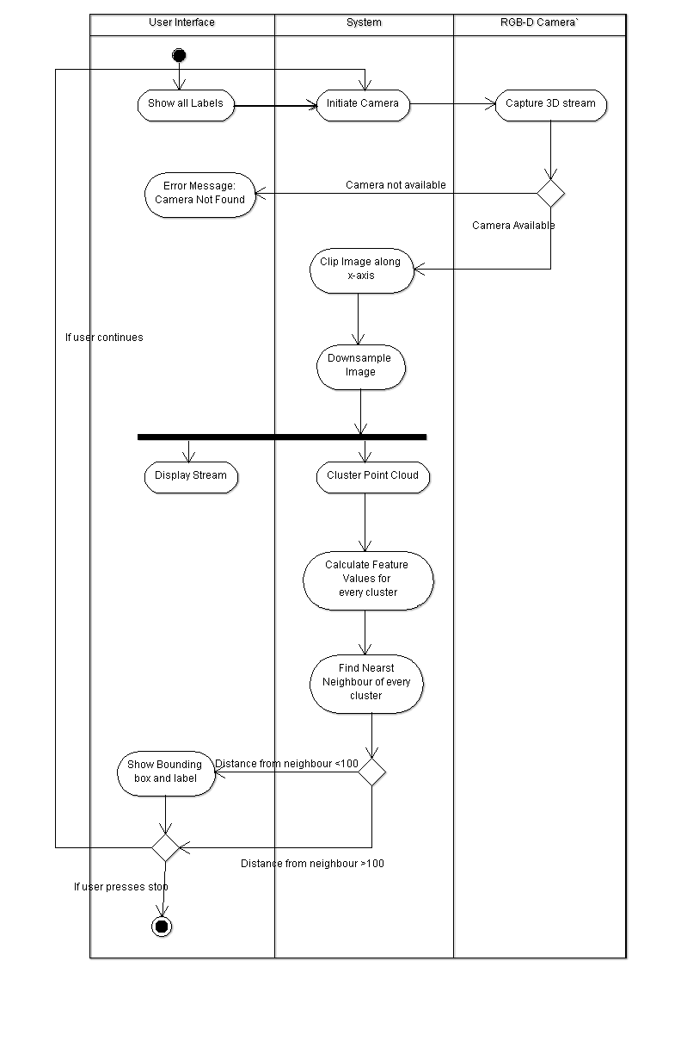

Figure 10: Activity Diagram

**3.4 TECHNOLOGIES USED:**

**3.4.1 HARDWARE AND SOFTWARE REQUIREMENTS**

**HARDWARE:-**

1. Microsoft Kinnect
2. RAM ≥ 1GB

**SOFTWARE:-**

1. C++ (std-98)
2. Point Cloud Library (≥ 1.6.0)
3. Boost (≥ 1.4.6)
4. Eigen (≥ 3.0)
5. FLANN (≥ 1.7.1)
6. VTK (≥ 5.6)
7. Openni-dev (≥ 1.3)

**4. PROJECT TIME AND TASK DISTIBUTION**

The overall time was divided into various tasks which are as follows:

* Research: A brief study of the topic was done, feasibility of the system was analysed and hardware and software requirements were finalised.
* Analysis: Re-evaluation of the requirements was done and the various hardware and software technologies were studied.
* Implementation of the system: The code of individual sensors was implemented and then all sensors were integrated together.
* Testing the system: In this phase test cases were designed and implemented. Both unit and integration testing were performed.

The project was successfully completed within 9 months.

**4.1 TIMELINE CHART**



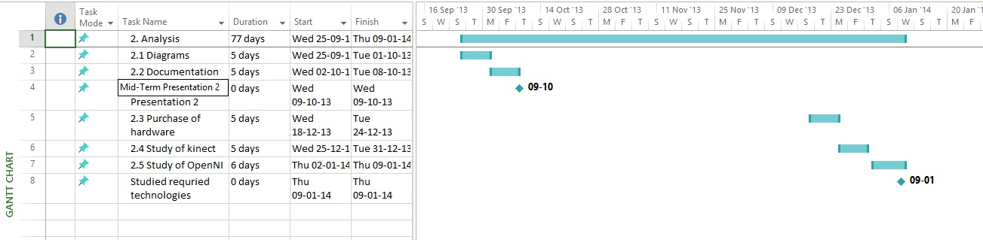

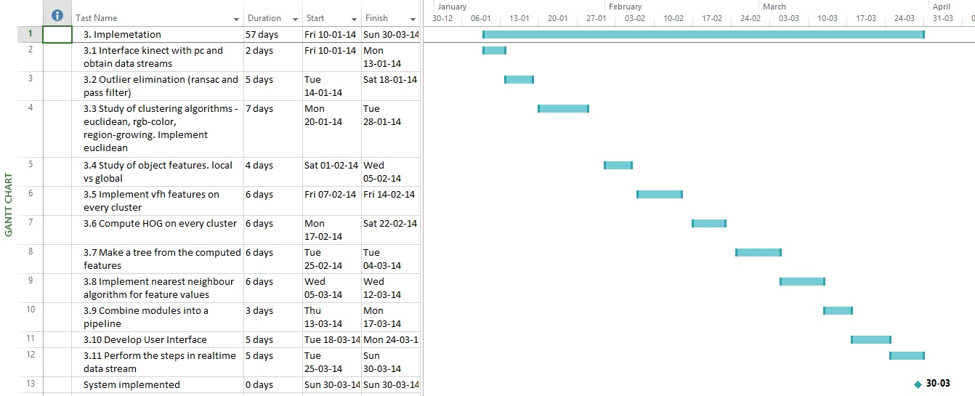

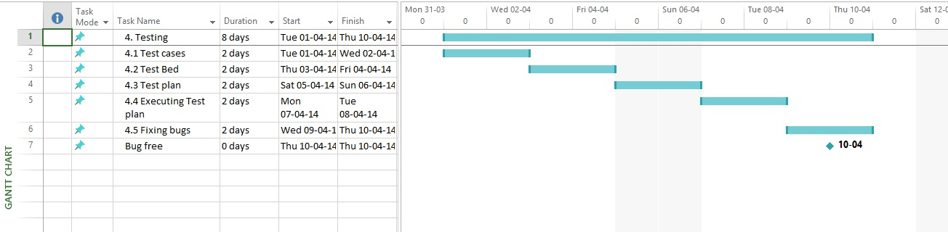

Figure 11: Timeline chart

1. **IMPLEMENTATION**

**Flow of activities:**

1. **Training phase**

* Capture the images of the objects to be trained from various angles
* Use the pass filter to eliminate the area around the object of interest
* Use the Euclidian clustering algorithm to form a cluster of points which belong to the object
* Determine the features of the cluster which represents the object and save it to the disk in form of a tree.

1. **Testing phase**

* Capture the image of the set of objects from which the concerned object is to be identified.
* Use the Euclidian clustering algorithm to form a cluster of points where each cluster is a distinct object
* Determine the features of each and every cluster
* Find the nearest neighbour of the clusters feature value in the tree
* Now assign the object a label of nearest neighbour.

**Algorithm:**

1. **Training:**

* Place the objects in different poses and capture its image from Kinect.
* Perform pass filter on every image.
* Downsample image with leafsize parameter.
* if no of points in pointcloud >=30% then remove largest plane.
* Extract Euclidean cluster by adjusting minimum, maximum cluster size and tolerance.
* Get cluster which represents each object.
* Determine the VFH for each cluster.
* Add the nodes of the computed VFH values in the tree.

1. **Testing**:

* Capture the image from Kinect.
* Clip the image based on x-coordinate.
* Downsample image with Leafsize parameter.
* Extract Euclidean cluster by adjusting Minimum, Maximum cluster size and tolerance.
* Determine the VFH for each cluster.
* Find the nearest neighbor of each and every cluster using the tree in training phase.
* if vfhs differences < threshold then label the object with nearest neighbors label
* else if (stop?) then end
* else goto step 1

**Flow Chart**

1. **Testing algorithm**

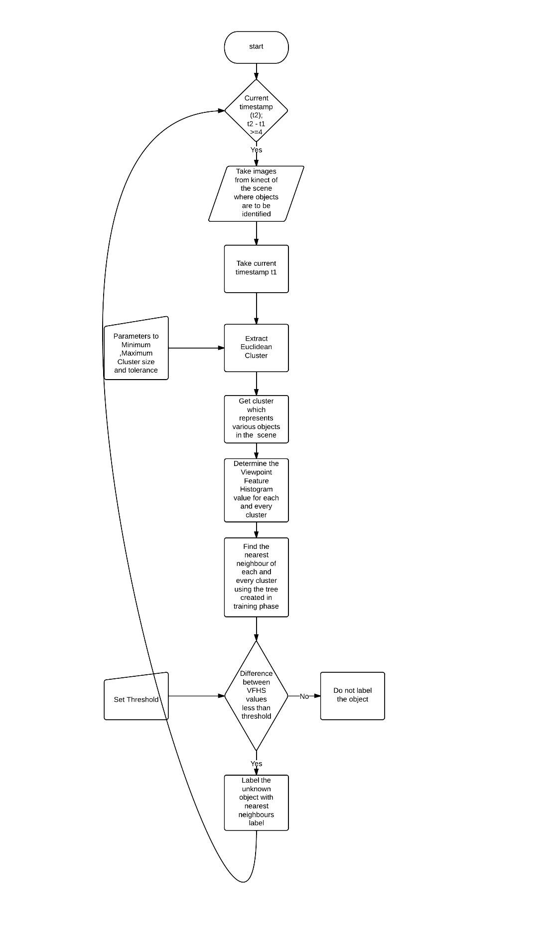

1. **Training algorithm**

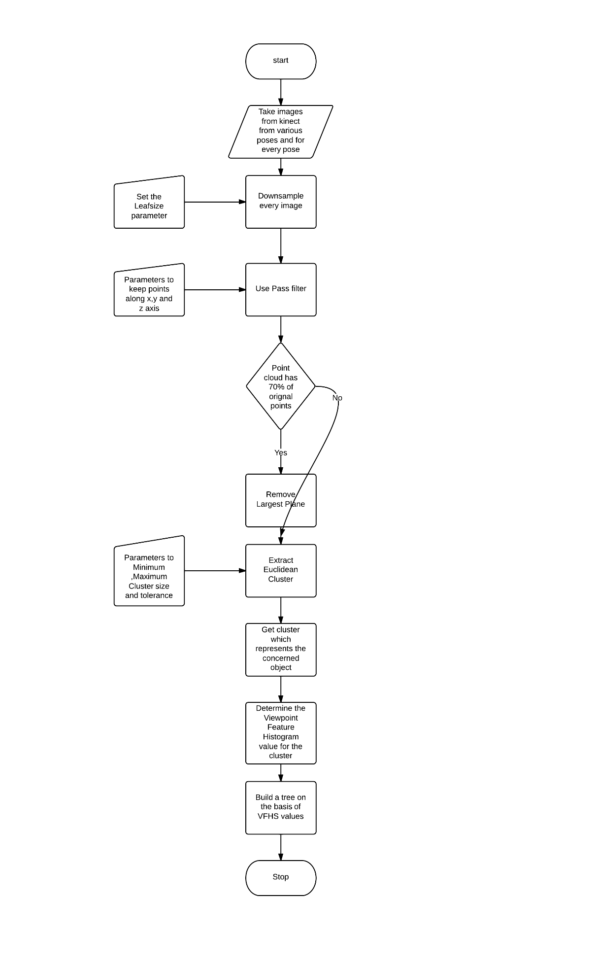

Figure 12: Flow Chart

1. **TEST CASES**

One of the major advantages of our application is that it can detect objects in different poses. So for testing purposes we place the objects in different angles and test accuracy of the system. Also its capability to detect objects in poor lighting conditions or completely dark environments is tested.

**Test Case 1:**

Objects are placed in bright light conditions. All the objects are correctly identified.

Result: Pass

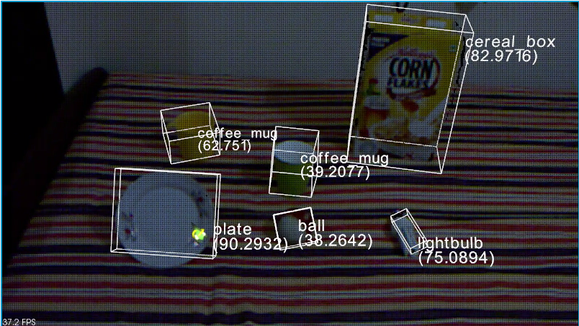

Figure 13: Test Case 1

**Test Case 2:**

The light is not as bright as before. Considerable portions of the objects of interest are not in visible to the naked eye. But as we can see the detection has not suffered.

Result: Pass

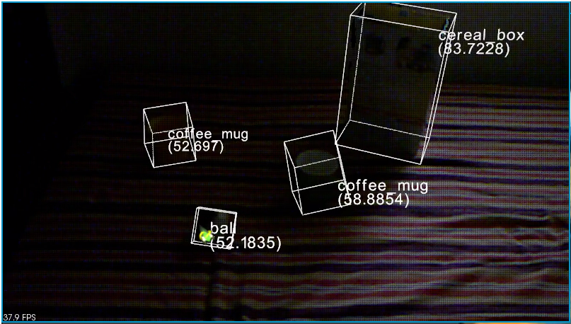

Figure 14: Test Case 2

**Test Case 3:**

In this case, the lighting conditions are same as before. But “cereal_box” object is facing down and “coffee_mug” is rotated. But they are still getting detected.

Result: Pass

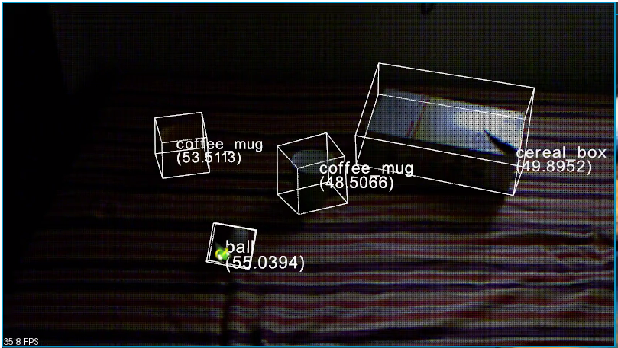

Figure 15: Test Case 3

**Test Case 4:**

In this, a new object ; “lightbulb” is introduced and “ball” is removed.

Result: Pass

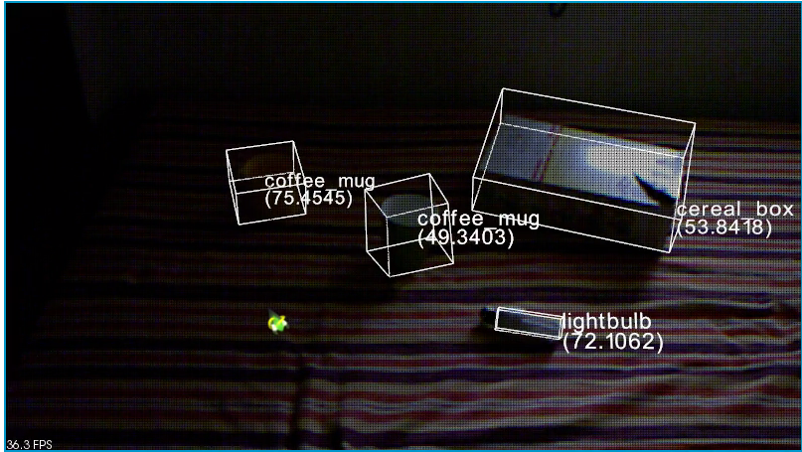

Figure 16: Test Case 4

**Test Case 5:**

In this, “cereal_box” is further rotated and a new object ball is introduced.

Result: Pass

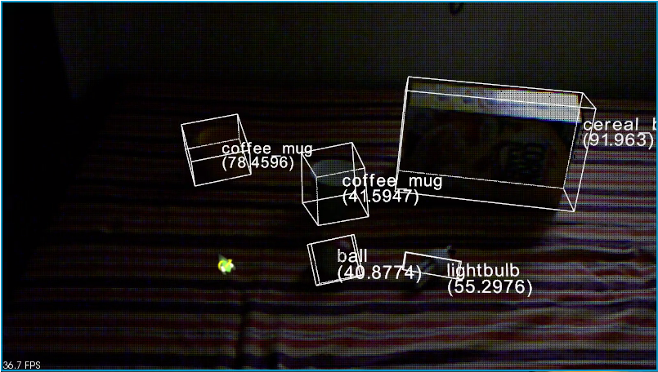

Figure 17: Test Case 5

**Test Case 6:**

In this, the positions and orientations of all objects are the same as before. But the environment is completely dark. We can see that the system is performing well.

Result: Pass

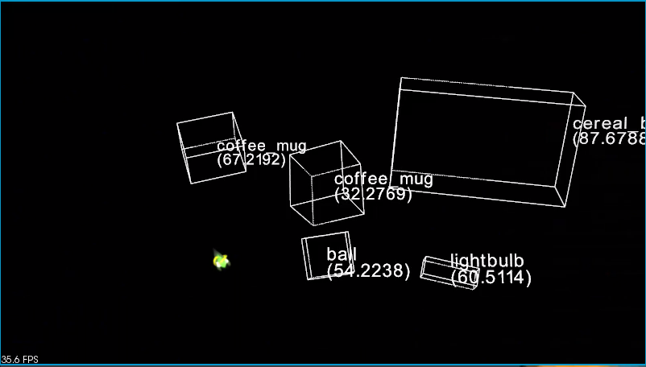

Figure 18: Test Case 6

**Test Case 7:**

We can rotate the objects and detect it properly in dark also. Verification is provided by the oriented bounding boxes.

Result: Pass

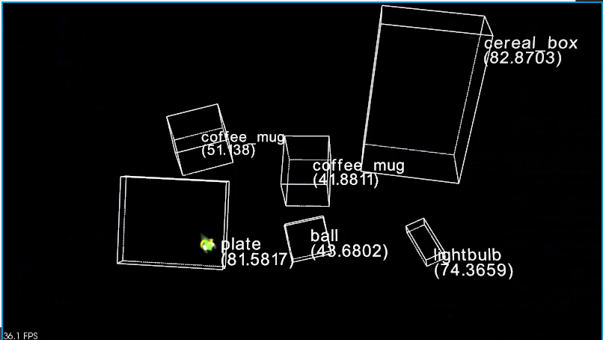

Figure 19: Test Case 7

1. **CONCLUSION & FUTURE SCOPE**

In this project, we presented a system that detects objects in a 3-dimensional point cloud and matches these objects with previously trained object models. The next step towards a solution should be to provide our recognition system with a point cloud that is built of multiple acquisition frames of the Kinect instead of just one. Thus, all acquired point clouds of a certain timespan should be merged into a single point cloud of the environment. The required technique for this is called simultaneous localization and mapping (SLAM).

Sufficient real-time algorithms for this task already exist, KinectFusion for example, and are even implemented in the Point Cloud Library. The table and object detection in such a merged point cloud would be more reliably and could be done by the presented software without code changes. Furthermore, the noise in the point cloud could be reduced with the statistical outlier removal algorithm that is already available in the Point Cloud Library.

Since my recognition module does only produce recognition hypotheses, but does not state whether an object is really one of the known objects or not, the recognition results have to be analysed in order to estimate the action that the robot should perform. One possible approach would be to get simply the four objects that have the smallest distance to their respective object model. However, if the number of known objects in the setting is unknown, it has to be done further research in order to estimate a Chi-square distance threshold that can distinguish whether a detected object is a trained object or not.

The presented system can be used in real-time applications, since the analysis of a single point cloud takes approximately 500ms. This duration can be inuenced by the various properties which the user can easily adjust.

**APPENDIX A**

**USER MANUAL:**

**STEP 1:**

Start the system using the file start.py. The following interface would be displayed. There are two tabs for the two functions that the system can perform. One is training the system to recognize new objects and the other finding objects in environment.

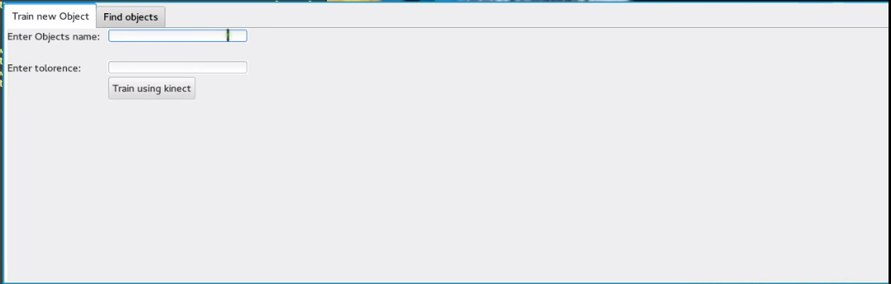

Figure 20: System Start

**STEP 2:**

To train new objects enter the name by which u want the object to be labelled and a tolerance value. The default is 0.05.

For example to train the system to recognize a bag, enter these values and hit “Train Using Kinect”

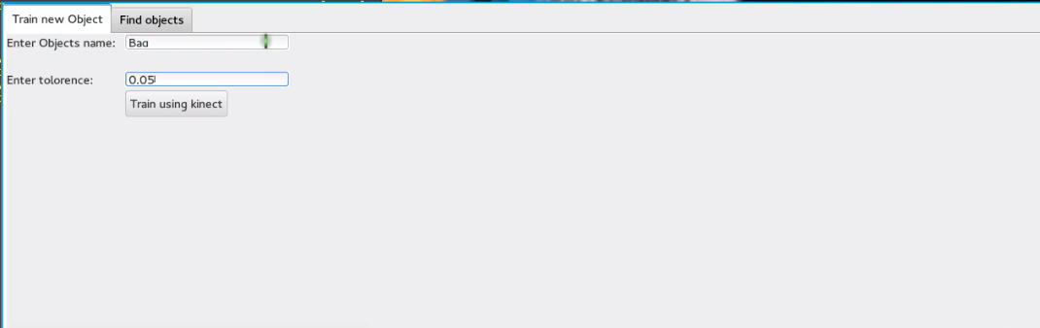

Figure 21: Enter object name

**STEP 3:**

To start detecting objects, go to the “Find Objects tab”. You will see the following window.

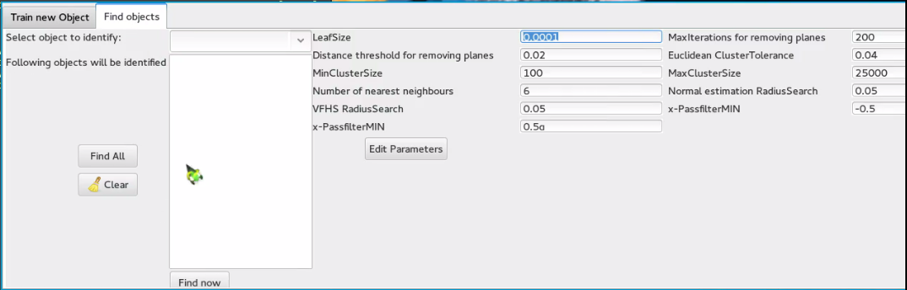

Figure 22: Detect Objects

The dropdown box contains the list of all the objects the system is trained to identify. What objects you’ll select will appear in the textbox below. You can click “Find All” to select all trained objects. All the parameters of the algorithm are displayed on the right with the defaults loaded. If you want to change some, enter new values and hit “Edit Parameters”. Select the objects and hit “Find now” to start.

**STEP 4:**

List of all trained objects.

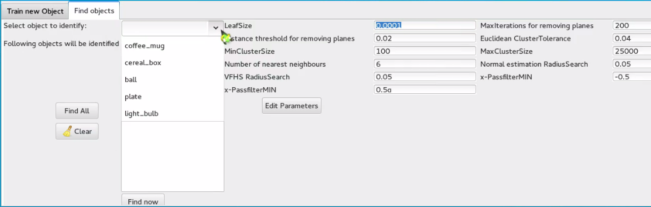

Figure 23: Select Objects

Objects coffee_mug, plate, ball, cereal_box, light_bulb are set for detection. Hit “Find Now”

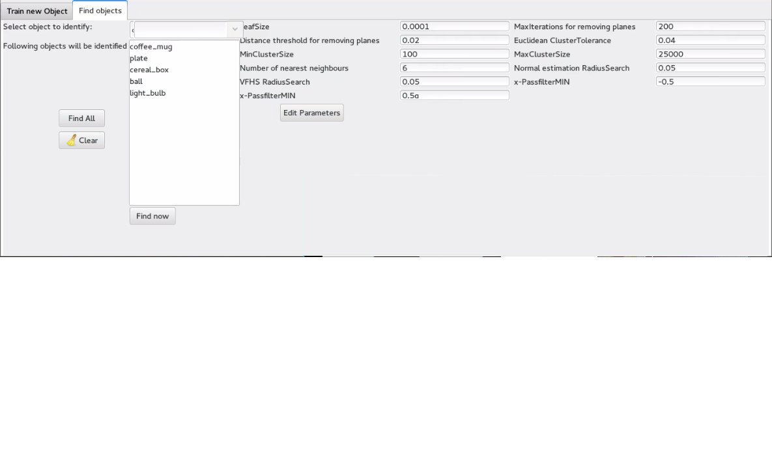

Figure 24: Begin Detection

This window should appear displaying the scene in front of the camera; with the selected objects getting detected.

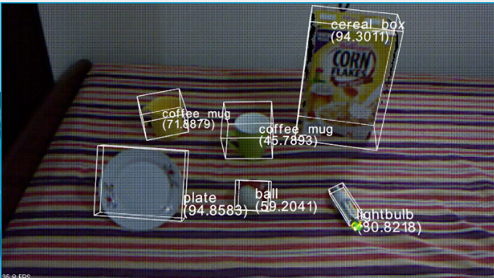

Figure 25: Detecting all objects

**STEP 5:**

Repeat precious step without selecting light_bulb and cereal_box.

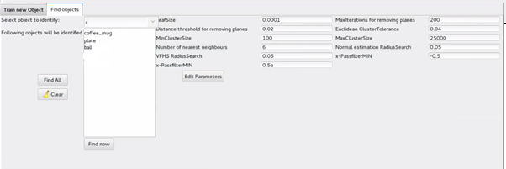

Figure 26: Begin Detection

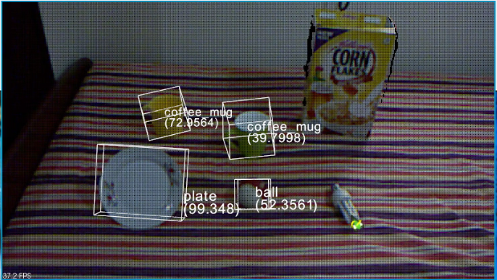

Figure 27: Detecting some objects

**APPENDIX B**

**CLASSES AND LIBRARIES:**

**Libraries:**

1. **Point Cloud Library (≥ 1.6.0):** The Point Cloud Library (or PCL) is a large scale, open project for 2D/3D image and point cloud processing. The PCL framework contains numerous state-of-the art algorithms including filtering, feature estimation, surface reconstruction, registration, model fitting and segmentation. These algorithms can be used, for example, to filter outliers from noisy data, stitch 3D point clouds together, segment relevant parts of a scene, extract keypoints and compute descriptors to recognize objects in the world based on their geometric appearance, and create surfaces from point clouds and visualize them -- to name a few.

PCL is released under the terms of the 3-clause BSD license and is open source software. It is free for commercial and research use. PCL is cross-platform, and has been successfully compiled and deployed on Linux, MacOS, Windows, and Android/iOS. To simplify development, PCL is split into a series of smaller code libraries that can be compiled separately.

1. **Boost (≥ 1.4.6):** Boost provides free peer-reviewed portable C++ source libraries.

It emphasizes libraries that work well with the C++ Standard Library. Boost libraries are intended to be widely useful, and usable across a broad spectrum of applications. The Boost license encourages both commercial and non-commercial use.

1. **Eigen (≥ 3.0):** Eigen is a C++ template library for linear algebra: matrices, vectors, numerical solvers, and related algorithms.
2. **VTK (≥ 5.6):** The Visualization Toolkit (VTK) is an open-source, freely available software system for 3D computer graphics, image processing and visualization. VTK consists of a C++ class library and several interpreted interface layers including Tcl/Tk, Java, and Python. VTK supports a wide variety of visualization algorithms including: scalar, vector, tensor, texture, and volumetric methods; and advanced modelling techniques such as: implicit modelling, polygon reduction, mesh smoothing, cutting, contouring, and Delaunay triangulation. VTK has an extensive information visualization framework, has a suite of 3D interaction widgets, supports parallel processing, and integrates with various databases on GUI toolkits such as Qt and Tk. VTK is cross-platform and runs on Linux, Windows, Mac and Unix platforms.
3. **FLANN (≥ 1.7.1):** FLANN is a library for performing fast approximate nearest neighbor searches in high dimensional spaces. It contains a collection of algorithms we found to work best for nearest neighbor search and a system for automatically choosing the best algorithm and optimum parameters depending on the dataset.
4. **Openni-dev (≥ 1.3.1):** The OpenNI framework is an open source SDK used for the development of 3D sensing middleware libraries and applications.

**BIBLIOGRAPHY**

[1] <http://www.pointclouds.org>

[2] <http://answers.ros.org>

[3] <http://www.boost.org/doc/libs>

[4] <http://www.cs.ubc.ca/research/flann>

[5] <http://www.pcl-users.org>